
NO.SSCG-A-12024/31/2011-Rectt.
Government of India
Staff Selection Commission (NER)
M/o Personnel, Public Grievances & Pension
Department of Personnel & Training
P.O. Assam Sachivalaya, Rukmini Nagar
Guwahati-781006.
Dated:__________2011.
To

Ms. Nalini Rani,
Editor (Advt.),
Employment News,
East Block-IV, Level-5,
R.K.Puram,
NEW DELHI-110 066.

Subject: - Advertisement of Selection Posts – Publication thereof.
Madam,

Please find enclosed an Advertisement notice (4 sets) in English alongwith a soft copy in CD for recruitment to the post of LIBRARIAN.

It is requested that the same may please be inserted in the Employment News/Rozgar Samachar issue dated 02.04.2011. A soft copy is also sent to you via e-mail: enewsadvt@yahoo.com

Encl: - As above.
Yours faithfully,

(S. Bose)
Deputy Director (NER).
Copy forwarded for information to:-

1. The Secretary, Staff Selection Commission, Block No.12, CGO Complex, Lodhi Road,
New Delhi-110 504.

2. The Under Secretary, DoPT, North Block, New Delhi-110001 in compliance to his
letter No.24012/07/98-Estt (B), dated 13th May, 2005, addressed to the Secretary,
SSC, New Delhi & a copy endorsed to all the RDs, SSC.

3. The U.S.(RHQ), Staff Selection Commission, Block No.12, CGO Complex, Lodhi
Road, New Delhi-110 504.

4. The Asstt. Media Executive, AD-II, DAVP, PTI Building, Parliament Street,
New Delhi-110003.

Enclo: - As above.

(S. Bose)
Deputy Director (NER).

Advt22011

(TO BE ADVERTISED ON 02.04.2011)
F.No.SSCG-A-12024/31/2011-Rectt.
Government of India
STAFF SELECTION COMMISSION
(North Eastern Region)

ADVERTISEMENT NO.3/2011-NER

CLOSING DATE: 30 days from the date of publication of the Advertisement.

APPLICATIONS ARE INVITED FOR THE FOLLOWING POST:-

Cat. No.NER(C)-01:One post of Librarian(General Central Service Group ‘C’ Non-Gazetted,
Non-Ministerial) in Central Academy for State Forest Service, Govt. of
India, Ministry of Environment & Forests, Burnihat, Assam.

Pay Scale : Rs.5200-20200 + Grade Pay Rs.2400/-.

Vacancy : 1(UR)

Age : 18-28 years (Relaxable for Government servants upto 40
years in accordance with the instructions or orders issued
by the Central Government).

E.Q. : (i) Degree from a recognized university or equivalent
(ii) Certificate in Library Science from the recognized
university or Institute.

D.Q. : Nil

I.P. : Burnihat, Kamrup, Assam

A.I.S.L. : Yes

J.R. :1.To maintain modern Library & Library catalogue efficiently.
2. Issue book to the trainees and receive from them.
3.To do necessary correspondence work and must have
correspondence skill and basic computer knowledge.
4. Any other work as assigned to by the officers.

P.O.P. : 2 (two) years.

(N.B. PH(OH/HH/VH) are not eligible)
Advt32011/1

INSTRUCTIONS TO CANDIDATES;
1.ABBREVIATIONS USED: EQ : Essential Qualification, DQ : Desirable Qualification, UR: Unreserved, SC: Schedule Caste; ST: Schedule Tribe, OBC: Other Backward Classes; PH: Physically Handicapped; CRFS : Central Recruitment Fee Stamps, AISL : All India Service Liability, IP : Initial Posting, , JR: Job- Requirement, POP: Period of Probation, i.e. that is.

2. Fee Payable: Rs.50/-(Rupees fifty) only: No fee for women candidate, Schedule Castes, Schedule Tribes.

Note: Mode of payment of examination fee has been indicated in Para 7 of important instructions.

3. Mode of Selection: Candidates fulfilling the minimum prescribed qualifications will be shortlisted on the basis of their educational qualifications, academic records, percentage of marks etc. or through a screening test at the discretion of the Commission. Candidates, thus, selected may be required to undergo a written proficiency test wherever applicable/required or considered necessary by the Commission at its discretion. The Commission holds discretion to fix different qualifying standard for different categories in the proficiency test wherever applicable. Candidates qualified on the basis of merit of proficiency test if any held, would be required to appear at the interview. Final select list would be prepared in order of merit as disclosed by the aggregate marks(marks of Proficiency Test wherever applicable and interview) finally awarded to each candidate taking into account the number of vacancies advertised and in that order so many candidates as are found suitable by the Commission would be recommended.

4. How to apply: Applications must be submitted in the format published in the Employment News/Rozgar Samachar. The applications should be submitted to the concerned Regional Director as per the address given below:
REGIONAL DIRECTOR (NER)
STAFF SELECTION COMMISSION
RUKMINI NAGAR,
P.O.ASSAM SACHIVALAYA,
GUWAHATI-781 006(ASSAM)

Note(1): Applications submitted on a format which is not exactly the same as published in the advertisement are
liable to be rejected summarily.
Note(2): The Commission may consider conducting the Screening Test or Proficiency test for the said post on the
same date or different date(s), at its discretion.

5.Documents to be attached with the application:
(i) Central Recruitment Fee Stamps of Rs.50/-affixed and clearly cancelled on the application form.
(ii) One recent passport size photograph to be pasted (NOT STAPLED) on the application and one
additional duly attested photograph to be enclosed.
(iii) Attested copies of certificates and mark statements showing age and educational qualifications. Candidates
have the option to either self-attested the photo-copies of various documents to be submitted by them or to
submit the copies of the documents duly attested by a Gazetted Officer. Any wrong attestation so as to
mislead the Commission or to gain access to the recruitment would lead to criminal/debar action against the
candidate, besides cancellation of the candidature. All original certificates will be checked at the time of
Personality Test/Skill Test, as the case may be, and the candidature is subject to the result of such scrutiny.
(iv) Documents in support of claim of age relaxation (admissible to Central Government Civilian Employees).
(v) Candidates in Government Service are to attach an undertaking that they have informed in writing to their
Head of Office/Department that they have applied for the post.

6.1: IMPORTANT INSTRUCTIONS:
(i) Candidates should note that only the Date of Birth as recorded in the Matriculation/Secondary Examination Certificate or an equivalent certificate as on the closing date of submission of application will be accepted by the Commission for determining the Age of eligibility and no subsequent request for its change will be considered or granted. Date of Birth will be reckoned as on the normal Closing date.
(ii) If necessary documents as mentioned in item 5 are not submitted alongwith the application, the application will be rejected summarily or at any stage of the recruitment process and no request for revival will be considered.
(iii) Incomplete or unsigned applications or applications without photograph or fee or applications received late will be rejected summarily. The Commission will not be responsible for postal delays.
(iv) The candidates may note that provisional certificates, mark sheets in support of age, educational qualifications signed by the Principals of Colleges or Schools are not acceptable by the Commission. Copies of such certificates, mark sheets issued by University’s/Board’s should be got attested by the competent officers and submitted alongwith the applications.
(v) If a candidate has changed his/her name or dropped/added part of his/her name after Matriculation/SSLC/Higher Secondary, he/she is required to submit an attested copy of Gazette Notification to the effect that he/she has changed his/her name after Matric etc. The changed name should also have been indicated in the Gazette Notification.
(vi) Wherever a proficiency test has been prescribed, the Commission may, at its discretion, call for interview only such candidates who obtain a certain minimum marks in proficiency test as decided by the Commission.

Advt.32011/2

(vii) Certificates in support of qualifications must have been obtained on or before the closing date from recognized University/Institution. Degree/Diploma etc. obtained through Open Universities/Distance education mode will not be accepted for the purpose of Educational Qualification unless it is recognized by Distance Education Council in terms of Ministry of Human Resource Development Notification No.44, dated 01.03.1995
published in the Gazette of India dated 08.04.1995 for the relevant period when the candidate acquired the relevant qualification.

(viii) CLOSING DATE: Completed application forms should be received by the concerned Regional Office of the Commission latest by within 30 days from the date of publication of the Advertisement.

6.2: Age relaxation: The upper age limit as prescribed will be relaxable:
(i) Upto a maximum of 40 years for Central Government Civilian Employees who have rendered not less than three years continuous service on regular basis (and not on ad-hoc basis). This is subject to furnish of duly filled in certificate as per the format in Appendix-I of the advertisement.
(ii) Upto a maximum of 5 years to candidates of Jammu & Kashmir who have ordinarily been domiciled in the State of Jammu and Kashmir during the period from 1.1.1980 to 31.12.1989(Any person intending to avail of the aforesaid relaxation shall submit the certificate from either District Magistrate within whose jurisdiction he/she had ordinarily resided or any other authority so designated in this behalf by the Government of Jammu and Kashmir to the effect that he had ordinarily been domiciled in the State of Jammu and Kashmir during the period 01.01.1980 to 31.12.1989).
NOTE-1: The Central Government Civilian Employees should have rendered not less than 3 years continuous service on regular basis (and not on ad-hoc basis) and should remain in Central Government service holding civil post in various Department/Offices of Government of India till the candidate receives Offer of Appointment from the Office/Department where the candidate gets finally recommended for appointment.
NOTE-2: Central Government Civilian Employees claiming the benefit of age-relaxation would be required to submit a Certificate as per Appendix-I issued by their office indicating length of service at the time of applying for the post to enable the Commission to decide their eligibility. They may send their applications directly to the Commission after intimating their Head of Office/Department and need not send another copy through proper channel. However, in case they decide to send Application through proper channel, they must ensure that the application complete in all respects, should reach Staff Selection Commission latest by the closing date. Applications shall be rejected if received late and/or not complete in all respects as provided in rules.

6.3: The crucial date for determining Age, EQ & certificates, etc. will be the closing date for receipt of applications.

7. Mode of payment of Fees: Candidates have to pay fee in the shape of CRFS. These stamps are available at all departmental Post Offices of the country. These stamps may be pasted at the top of the application in the space provided for the purpose. These Recruitment fee stamps must be got cancelled from the counter clerk of any post office including the post office of issue with the date stamp of post office in such a manner that the impression is clear and distinct to facilitate the identification of the date and the post office of issue at any subsequent stage. After getting the Recruitment fee stamps cancelled from the post office, the candidate may submit the application, complete in all respects, to the concerned Regional Office of the Commission in the usual manner after completing other formalities.
(i) Fee once paid will not be refunded under any circumstances.
(ii) Fee paid by cash, Bank Draft or Pay Order, Indian Postal Order will NOT be ACCEPTED.

8. Vacancies mentioned above are subject to variation.

9. Canvassing in any form will disqualify the candidate.

10. The job requirements of the post are indicated below the details of the post to facilitate the candidates to understand the main functions to be performed after appointment to the posts.

11. Submission of Certificates in support of Essential Qualifications:
(1) The documents/certificates for EQ are to be furnished by the candidates along with their applications.
Otherwise, their candidature is liable to be rejected summarily at any stage of the recruitment process.
(2) Only attested copies of certificates and mark sheets are required to be sent. Even the photocopies of
certificates and mark sheets are required to be attested. The Original Certificates/Mark sheets must not
be sent with the application.

12. All candidates in Government service, whether in a permanent or in temporary capacity or as work charged employees other than casual or daily rated employees, or those serving under Public enterprises, will be required to submit an undertaking that they have informed in writing to their Head of Office/Department that they have applied for the post. The candidate may send their applications directly to the Commission after intimating to their Head of Office/Department and need not send another copy through proper channel. However, in case, they decide to send Application through proper channel, they must ensure that the application complete in all respects reaches Staff Selection Commission by the closing date. Applications shall be rejected if received late and/or not complete in all respects as provided in rules.

Advt.32011/3

13. Candidates should note that in case a communication is received from their employer by the Commission withholding permission to the candidate applying to appear at the proficiency test/screening test/interview, their applications shall be rejected/candidature shall be cancelled.

14. No persons-(a) who has entered into or contracted a marriage with a person having spouse living; or (b) who having a spouse living has entered into a contracted a marriage with any person, shall be eligible for appointment to service.
Provided that Central Government may, if satisfied that such marriage is permissible under the personal law applicable to such person and the other party to the marriage and there are other grounds for so doing, exempt any person from the operation of this rule.

15. A candidate must be in good mental and physical health and free from any physical defect likely to interfere with the efficient discharge of his duties as an Officer of the service. A candidate who after such medical examination as may be prescribed by the competent authority, is found not satisfying these requirements, will not be appointed.

16. Any dispute in regard to this recruitment will be subject to Courts/Tribunals having jurisdiction over the place of the concerned Regional Office of the Staff Selection Commission where the candidate has submitted the application i.e. Staff Selection Commission(NER), Guwahati, Assam.

17. The application complete in all respects should reach the Regional Director, Staff Selection Commission (NER), Guwahati by the closing date mentioned in para 6.1(viii). Application shall be rejected if received late and/or not complete in all respects as provided in the rules.

18. The envelope containing the application must be superscribed in bold letters as ‘APPLICATION FOR THE POST OF____________________ ADVERTISED VIDE CATEGORY NO.NER( )___________OF ADVT. NO.3/2011-NER.

19. The Commission will have the discretion to fill up more vacancies in equivalent comparable posts from this advertisement.

Address for sending application: Regional Director (NER), Staff Selection Commission,
Rukmini Nagar, P.O.Assam Sachivalaya, Guwahati-781006.
_____________________________________________________________________________________________
INSTRUCTIONS FOR FILLING UP APPLICATION FORM FOR SELECTION POSTS
1. It may be noted that the Commission uses Common Application Form for all its recruitments. Please go
through the notice for the Recruitment and also these instructions carefully before applying for any of the
posts mentioned in the Notice. You must satisfy yourself that you are eligible for the post for which you are
applying.

2. Use only blue/black pen for filling up the Application Form.

3. Instructions have been given for most items in the application itself which should be gone through carefully
before filling up the boxes. For items for which instructions are not available or require further clarification,
further instructions given below may be gone through carefully.

4. Column 10 may be filled up carefully.

5 Column No.12.1-The category code for filling up this column is available in the Commission’s website http://ssc.nic.in.

6. Column No.12.2- The age should be indicated as on closing date for receipt of applications.

7. Column No.13: relating to preference for posts may be left blank.

8. Column No.17 Educational Qualification: The list of Educational Qualification and subjects mentioned
in Appendix VII is not exhaustive. Candidates who possess any educational qualification or studied any
subject other than those mentioned in the list at Appendix-II may use ‘Others’ for qualification and/or
subject code.

9. Candidates should read carefully the Essential Qualification required for the post for which they are applying
and ensure that they fulfill the same. Documents in support of Essential Qualifications should
invariably be furnished along with the application failing which the applications will be
summarily rejected.

10. Column No.19: Write your complete communication address including your Name in English in capital
letters or in Hindi with blue/black ball pen. Do not forget to write 6 digit PIN in the boxes.

11. Column No.20: Paste your recent photograph of size 4cmX5cm. Do not staple and do not get the photo
attested. Please note that your application shall be rejected summarily without photograph[ph.

12. Column No.21 and 22: Please do sign in running hand. Unsigned applications will be rejected. Signature
in capital letters of English shall not be accepted and your application shall be summarily rejected. Variations
in the signature will render the application liable to be rejected.

Advt32011/4

APPENDIX-I

FORM OF CERTIFICATE TO BE SUBMITTED BY CENTRAL GOVERNMENT CIVILIAN EMPLOYEES SEEKING AGE-RELAXATION
(To be filled by the Head of the Office or Department in which the candidate is working)
(Please see Para 6.2 of the Notice)

It is certified that *Shri/Smt/Km.__________________________________ is a Central Government Civilian

employee holding the post of _______________________ in the pay scale of Rs. ______________ with 3 years

regular service in the grade as__________.

Place:

Date: Signature___________________

(*Please delete the words, which are not applicable) Name_______________________
Office Seal

Advt32011/5

APPENDIX-II
Subject Code for Educational Qualification
Subject of Educational Qualification | Code | Subject of Educational Qualification | Code
History | 01 | Malayalam | 42
Political Science | 02 | Telugu | 43
Economics | 03 | Kannada | 44
English Literature | 04 | Tamil | 45
Hindi Literature | 05 | Marathi | 46
Geography | 06 | Gujarati | 47
Commerce | 07 | Urdu | 48
Law | 08 | Sanskrit | 49
Physics | 09 | OTHERS | 50
Chemistry | 10 | Aeronautical Engineering | 51
Mathematics | 11 | Chemical Engineering | 52
Statistics | 12 | Microbiology | 53
Geology | 13 | Forensic Science | 54
Geophysics | 14 | Space Engineering | 55
Botany | 15 | Rocketry | 56
Zoology | 16 | Telecommunication Engineering | 57
Agriculture Science | 17 | Social Work | 58
Civil Engineering | 18 | Sociology | 59
Electrical Engineering | 19 | Criminology | 60
Mechanical Engineering | 20 | Bio-Physics | 61
Electronics Engineering | 21 | Bio-Chemistry | 62
Electronics & Power Engineering | 22 | Bio-Technology | 63
Electronics & Communication Engineering | 23 | Communication | 64
Electronics Instrumentation Engineering | 24 | Electronics | 65
Agriculture Engineering | 25 | Radio Engineering | 66
Computer Science | 26 | Radio Communication | 67
Computer Application | 27 | Metallurgy | 68
Information Technology | 28 | Textile Technology | 69
Library Science | 29 | Rubber Technology | 70
Accountancy | 30 | Plastic Engineering | 71
Work Accountancy | 31 | Polymer & Rubber Technology | 72
Business Administration | 32 | Physical Education | 73
Mass Communication | 33 | Agronomy | 74
Journalism | 34 | Plant Breeding | 75
Mass Communication & Journalism | 35 | Genetics | 76
Pharmacy | 36 | Automobile Engineering | 77
Photography | 37 | Marine Engineering | 78
Printing Technology | 38 | Naval Architecture | 79
Nursing | 39 | Operations Research | 80
Assamese | 40 | Instrumentation Engineering | 81
Bengali | 41 | Wildlife Management | 82
Essential Educational Qualification Code
Educational Qualification | Code | Educational Qualification | Code
Matriculation | 01 | B.Lib | 20
Intermediate | 02 | B.Pharma | 21
Certificate | 03 | ICWA | 22
Diploma | 04 | CA | 23
BA | 05 | PG Diploma | 24
BA(Hons.) | 06 | MA | 25
B.Com | 07 | M.Com | 26
B.Com(Hons.) | 08 | M.Sc | 27
B.Sc | 09 | M.Ed | 28
B.Sc(Hons.) | 10 | LLM | 29
B.Ed | 11 | ME | 30
LLB | 12 | M.Tech | 31
BE | 13 | M.Sc(Engg.) | 32
B.Tech | 14 | MCA | 33
AMIE(part A & part B) | 15 | MBA | 34
B.Sc(Engg.) | 16 | OTHERS | 35
BCA | 17
BBA | 18
Graduation issued by Defence (India Army,  Air Force, Navy) | 19

Advt.32011/6

Advt.32011/7

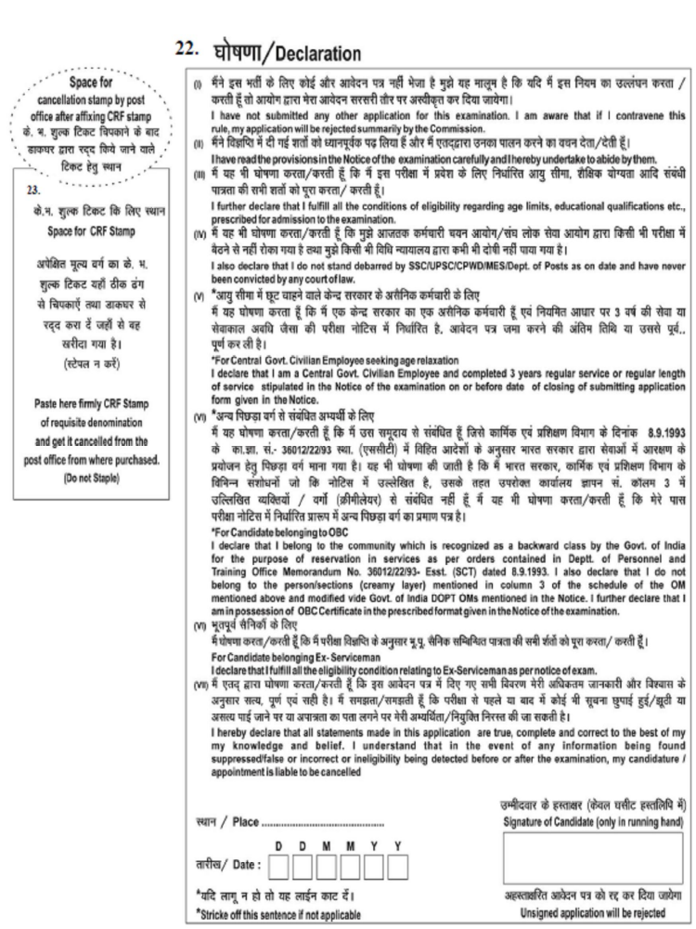

Advt.32011/8

